Maya Angelou Personality
Student Name:
Institution Affiliation:

Maya Angelou Personality
Abstract
My project involved describing and conceptualizing the personality of a historical figure known as Maya Angelou. The project begins with a brief description of Maya's life history which is described notably with the main historical aspects of personality being brought out more clearly. The project describes Maya in the psychoanalytic and the humanistic perspectives of personality.
Under the Psychoanalytic personality perspective, the project describes how early childhood experiences shape Maya's personality. The perspective is reinforced by the Eric Erikson’s theory of psychosocial development stages. Maya's development is viewed in contrast to how she was successful in all the eight stages of psychosocial development.
Next, under the Humanistic perspective, the project described the focus of personality development on personal awareness, free will and also psychological growth. The project utilizes Carl Roger’s theory to emphasize more about humanistic personality perspective. Maya’ personality development is compared to different Roger believes especially believe in self-actualization and development of the self-concept. The project concludes with a general summary of Maya’s personality.
Brief Live History
Maya Angelou was an American civil rights activist, memoirist, singer, and poet. She made several publications including autobiographies and books of essays. She was born on St. Louis, Missouri on April 4, 1928. She received the Maya from her brother whom they lived together at their grandmother place after the divorce of their parents (Gale, 2016). Maya develops many personality traits from her grandmother including self-confident and pride. However, Maya was devastated when she was at the age of eight years upon visiting St. Louis by the boyfriend to her mother. After testifying against her mother’s boyfriend, several of her uncles beat him up to death.
According to Gale, (2016), Maya personality was further affected since after she knew that she had caused someone death after testifying her name, she refused to speak for almost five years. She believed that speaking made her cause someone death. Several challenges characterized her scroll life. She attended public school in Arkansas then later went to California. While proceeding with her school life, Maya was the first ever Africa America female to become a streetcar conductor in California specifically San Francisco. Maya at the age of sixteen years gave birds to a son and later was married to a Greek, Sailor Tosh Angelos. However, her marriage only lasted for very few years.
Before going on to a career in theatre, Maya had studied drama and dance. Maya participated in acting several plays including Cabaret for Freedom. She collaborated with several other writers to script plays and drama that they performed in collaboration. In the 1960s, Maya lived in Egypt where she acted as an associate editor for The Arab Observer. She later resided in Ghana where she contributed a lot to several articles including The Ghanaian Times. She was featured in broadcasting several Ghanaian programmes. From 1964 to 1966, Maya was featured as the editor of the Africa Review in Accra. Due to the personality she had developed in the different positions she had served around Africa, upon return to the united states, she was requested to serve as Northern coordinator for the Southern Christian Leadership conference by that time civil rights leader Dr. Martin Luther King, Jr. Maya is remembered as a successful author of several books and received several awards. She also works in television as a writer-producer (Isti’anah, 2017).
The Psychoanalytic Personality Perspective
Under this personality perspective type, the unconscious mind and early childhood experiences are the primary focus. The founder of this personality type believed that all things and aspects hidden in the unconscious mostly get revealed in differed ways including slips of the tongue, dreams, and even free associations. It is believed that no behavior is without its clear cause and its always determined (Levenson, 2016). The childhood experiences will still affect the adulthood emotions and behaviors. The overall individual personality is shaped by the various conflicts that happen throughout an individual’s childhood development. For instance, the child learned defense mechanisms are always depicted in adulthood.
Maya encountered several incidences during her childhood whose results were depicted in her adulthood. Maya was not aware that her word of mouth could cause death. She knew that reporting the rape case was only made to make people aware that she was raped and they had to know who raped her. Centrally to her expectations, her uncles beat the man who raped to death. The incidence immediately changed her emotions and behaviors making her even to stop talking for approximately five years. She always feared that everything she could speak about could cause harm to those around her. Her behavior transformed completely after that incidence. Even after she started talking, she was always careful of all the words she used. During her visitations to different countries in Africa and also upon returning to the united states, she was still a lady of few words (Levenson, 2016).
Through Maya, we can also precisely learn that there is no behavior without a cause and therefore determined. She stopped speaking since speaking had caused death. She confidently believed that keeping quiet would prevent death. In her future career, she always went on a quiet moment while writing her books and autobiographies (Levenson, 2016). Some of Mayor’s encounters that she never spoke out during the entire period when she had refused to speak were later depicted in her different published works. Maya's perception of marriage changed after her parents divorced and sent her and the brother to live with the grandmother. The parent divorce instance also affected Maya’s marriage which even never lasted for several years.
According to McAdams, & Zapata-Gietl, (2015), Eric Erikson is one of the many significant theorists with his theory of psychosocial development that supports the psychoanalytic perspective of personality. Erick in his theory mostly emphasized on the identity crisis, the social elements of personality development, and also how an individual personality is shaped over the entire lifespan. Maya’s personality has been formed in different ways according to the eight stages of psychosocial development depicted by Erick. Her personality developed since her birth till her death.
According to Eric, the first stage of lifespan development is Trust vs. Mistrust. The stage occurs between the ages of birth and two years sand majorly involves the development of a sense of trust from the caregivers and the entire world according to the environment the child is exposed to. Maya, in this case, lived both with the parents between the birth and two years which made her develop a sense of trust from the parents. Due to the parental care, she developed a psychological quality of hope. She hoped that she could stay with such attention from the parents as she grew up (McAdams, & Zapata-Gietl, 2015).
Autonomy vs. Shame and Doubt is the second stage of psychosocial development according to Erick. The stage takes place between two years and three years of age in which a child is supposed to develop personal control and a sense of independence. Successful children under this stage are always able to remain determined and create a sense of goodwill. Maya, in this case, had started developing a sense of independence and personal control which was interrupted instantly after the parents divorced. Maya was not successful in this stage due to the end of her parents’ marriage. She never precisely developed any sense of determination hence grew up being less determined on herself (McAdams, & Zapata-Gietl, 2015).
Initiative vs. Guilt is the third stage of psychosocial development according to Erick. The stage occurs between the ages of three and six ages where children are expected to explore their environments and become more responsible for their controls. Under this stage, Maya was merely affected by the divorce instance of the parents. Before even starting exploring the environment she was born in, she was sent to the grandmother where she encountered a new and unfamiliar environment. She had to begin from zero and start adopting this new environment. She had even to start familiarizing herself with her grandmother and start learning new aspects from her. She had to start again developing a sense of trust from the grandmother. Maya was not successful in this stage of development hence was unable to establish a sense of purpose (McAdams, & Zapata-Gietl, 2015).
The fourth stage of development is Industry vs. inferiority which takes place between the age of five years and the age of 11 years. The stage is always focused on the development of personal pride and also making some accomplishments. While trying to develop personal pride, Maya was interrupted. She was raped at the age of eight years which caused her to lose morale of different things. She was entirely sure that visiting St. Louis had no problem. She even trusted her mother's boyfriend who raped her. However, the rape case never distorted her from making some accomplishments. She knew that reporting the mother’s boyfriend to her uncles was part of achievements. What she thought as an accomplishment turned to be a failure to him and impacted her personality much since the reporting caused death. The act made her not to develops any sense of competence (McAdams, & Zapata-Gietl, 2015).
The fifth stage of development is identity vs. confusion which occurs in the teen years. Under this stage, teens are expected to explore themselves personally. This was the most challenging stage to Maya as she undertook her studies. She even went to the extent of becoming a conductor in California. However, she never despaired and pushed on to achieve what she needed from the school to pursue her future writing career. It is during this stage that Maya gave birth to a boy hence started having challenges in raising the kid. She struggled to develop s sense of fidelity under forged health identity. Due to the various difficulties, she continued to encounter in her teens, and she never completed this stage well hence ended up being left confused about her different society and life roles and places (McAdams, & Zapata-Gietl, 2015).
Intimacy vs. Isolation is the sixth stage of psychosocial development which takes place in early adulthood. Under this stage, adults are expected to forge healthy relationships with others. Under this stage, Maya was able to get married to a Greek Sailor and get divorced after sometimes. She was successful in this stage since she visited Africa during her early adulthood. During her stay in Africa and especially Egypt, she was able to forge healthy relationship s with other by acting in several plays. She also got support from other African famous writers and guided her on how to write. She contributed to several articles and even went father to be nominated in various positions including appointment to become an associate editor of The Arab Observers. Maya was precisely successful in this stage hence being able to a forum better committed, nurturing and lasting relationships with all those she met within her career (McAdams, & Zapata-Gietl, 2015).
The seventh stage of development is Generativity vs. stagnation which occur at the middle of adulthoods. Under this stage, individuals concentrate much-contributing something to society hence being able to leave a mark on the world. It is during her mid-adulthood that Maya focused on her career. She first published the first book; I Know Why the Caged Bird Sings which was a huge success. Many people loved the book which encouraged her further. The publication tells about Maya’s life up to the age of sixteen years which provided the current children with a general point of view of the confusing world of adulthood. The conclusion of the book described Maya having regained her self-esteem and precisely caring for her newborn baby which help the readers to gain knowledge that it is possible after a long struggle for one to gain back self-esteem and move on with life in a more smooth way. She continued publishing books which inspired and continue to encourage most individuals in the world. Her other publication in her mid-adulthood includes Gather Together in My Name (1974), Gettin’ Merry Like Christmas (1976), The Heart of A Woman among others (McAdams, & Zapata-Gietl, 2015).
According to Erick, Integrity vs. Despair is the final stage of psychosocial development which takes place in late adulthood. The final stage majorly entails an individual reflecting on life. Maya during her late adulthood tries to evaluate herself and finds out that she has become a successful author. Maya had also been awarded several awards including National Book Award, Tony Award nomination, and Pulitzer Prize nomination. For different achievements. All her poetry and novel works were all liked by many across the world. In her life, she was also engaged in writing and producing several television films. Maya had developed a sense of wisdom and integrity since when she evaluated her life, she got a feeling of satisfaction (McAdams, & Zapata-Gietl, 2015).
Generally, Maya struggled to become successful in most of Erick's Stages of Psychosocial development. Maya's early childhood exposure defined her later stages of development. The stay will the grandmother shaped her personality making her more interactive and collaborative in undertaking different activities later in life. She is known to be a successful author and has been rewarded severally since her behaviors and emotions well shaped her personality.
The Humanistic Personality Perspective
The primary focus of this perspective of personal perspective is personal awareness, free will, and psychological growth. It is mostly centered on how an individual can achieve their potential via utilization of human nature (Bland, & DeRobertis, 2017). Under this perspective, human beings are made to grow, change and develop their potential. The recent movement of this perspective psychology is trying to ensure people live healthier and happier.
Maya in our case was always determined to achieve her full potential. She had to explore her potential in a hard way. Before landing to her career, she was forced first to learn drama and dance. She can make her potential grow through collaboration with different people especially actors while in African. She further exploited her potential through her different works that she was able to publish (Geetha, & Maheshwari, 2018). Maya believed that she was capable of achieving various goals hence was free willing to engage in different activities such that in the looming run she can be successful. The fact that her parents had divorced did not hinder herself from achieving her full potential since she used that human nature to struggle and acquire the best.
Carl Rogers psychological theory majorly supports the humanistic personality perspective. Roger had a precise believe that individuals usually possess an inherent need to grow and achieve their potential. He also thought that the primary driver of behavior was the need to achieve self-actualization (Shefer, Carmeli, & Cohen‐Meitar, 2018). Maya hand an inherent need to grow and realize her potentials but lacked explicit support. She had to struggle in the streets while trying to explore her potential. Even after landing to her career, she also went further to move to Africa in search of realization of full potential. After much exploration of different activities across her career in Africa, she came back to the united states where Dr. Martin Luther King Jr. sported her and nominated her to serve as northern coordinator for the Southern Christian leadership conferences.
According to Shefer, Carmeli, & Cohen‐Meitar, (2018), Rogers had a strong belief in the development of the self. He believed that an individual life experience usually shaped that ongoing process of formation of a healthy self-concept. Individuals who majorly cope more effectively with life challenges typically have a stable sense of self-making them more confident. According to Rogers, parenting usually has a significant effect on self-concept since it begins to develop during childhood. Children who receive unconditional love from their parents typically foster a healthy self-concept. However, those earning less care and love usually end up feeling unworthy and developing a lower self-concept.
Maya’s different life experiences shaped the development of her self-concept. Maya more very much confident in herself, an aspect she learned from her grandmother making her able to cope with different life challenges that she encountered. This can be evidenced how strong she grew up and exposed herself to street work even after being raped at the age of eight years. Maya parents’ marriage ended when she was only three years old her development of self-concept was not much influenced by parenting (Shefer, Carmeli, & Cohen‐Meitar, 2018). Further, under the care of her grandmother, she refused to speak for almost five years suggesting that caregiving contributed nearly nothing to self-concept. Maya grew up feeling unworthy and having less self-esteem. However, she later regained her self-esteem implying that the development of her self-concept was in a hard way.
Conclusion
Maya was quite adaptable and ended up fitting in most vocational fields and social setups. There were no specific values that caused an imbalance in Maya's personality and entire life, but she had to persist and work hard ion the efforts of developing the unique strength and the desires she usually had. Throughout Maya's whole life, we can learn to e wisely assertive.

References
Bland, A. M., & DeRobertis, E. M. (2017). The humanistic perspective. Encyclopedia of Personality and Individual Differences. http://dx. doi. org/10.1007/978-3-319-28099-8_1484-1.
Gale, C. L. (2016). A Study Guide for Maya Angelou's" Still I Rise". Gale, Cengage Learning.
Geetha, B., & Maheshwari, K. (2018). Self-Actualization in the Protagonist of Maya Angelou’s Memoir: A Humanistic Psychological Approach. Language in India, 18(6).
Isti’anah, A. (2017). Stylistic Analysis of Maya Angelou’s Equality. Lingua, 11(2), 85-89.
Levenson, E. A. (2016). The purloined self: Interpersonal perspectives in psychoanalysis. Routledge.
McAdams, D. P., & Zapata-Gietl, C. (2015). Three strands of identity development across the human life course: Reading Erik Erikson in full. The Oxford handbook of identity development, 81-94.
Shefer, N., Carmeli, A., & Cohen‐Meitar, R. (2018). Bringing Carl Rogers Back In: Exploring the Power of Positive Regard at Work. British Journal of Management, 29(1), 63-81.

Appendices
Appendix I: Image of Maya Angelou
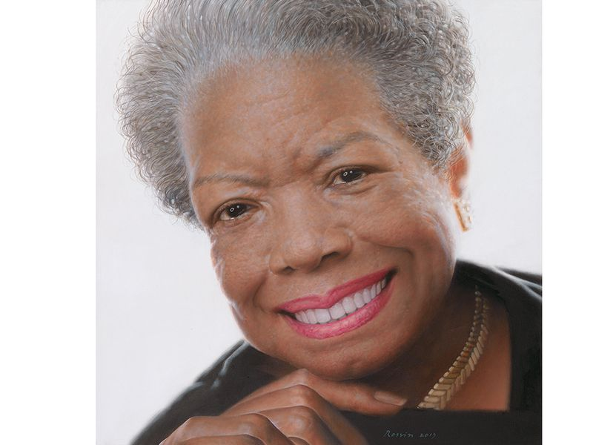

Appendix II: Eric Erickson’s Psychosocial Stages of Development
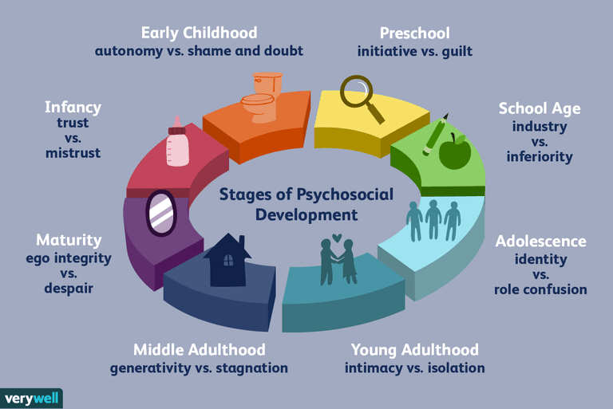

Appendix III: Carl Roger’ Personality Theory
